**Leader Overview**

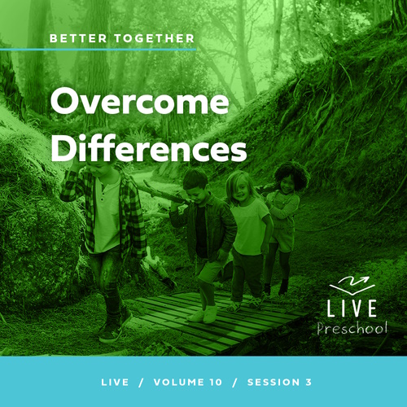

**Volume Overview**

**Better Together**

*The Christian life is never lived alone. When we become a Christian, we’re adopted into God’s family. We’re welcomed into a community. We’re meant to live and grow in faith together. But that takes humility and intentionality. We grow together as we pray and study Scripture together. We bear responsibility for one another by our encouragement and our honoring of those in authority. God is growing us together as one body, one family.*

**Session Overview**

**Overcome Differences**

*In this* **Live** *session, preschoolers will discover that they can solve disagreements with God’s help. They will explore the story of Paul and Peter leading the Early Church in working out differences of beliefs. Kids will see that seeking God’s wisdom and treating each other kindly are important when believers disagree.*

**Bible Lesson**

The Church Meets to Navigate Challenges

[Acts 15:1–20](https://ref.ly/logosref/Bible.Ac15.1-20)

**Faith Fact**

We can solve disagreements with God’s help.

**Faith Verse**

[Ephesians 4:3](https://ref.ly/logosref/Bible.Eph4.3) (NLT)

Make every effort to keep yourselves united in the Spirit, biding yourselves together with peace.

**Preparing for the Session**

**Leader Preparation Time: 20–25 Minutes**

|  |
| --- |
| ***You Will Need***  ***Preservice Activities***  *• Toys*  *• Softball*  *• Baseball*  *• Chocolate and vanilla sandwich cookies*  ***Large Group***  *• Bible*  *• Worship songs (Song suggestions: “Alive with You” Lyric Video by Gateway Kids Worship; “I Need You” Lyric Video by Gateway Kids Worship; “Good to Me” Lyric Video by Elevation Church Kids*  *• For groups not using a phone or tablet only, add:*  *• Projector or TV*  *• Laptop*  *•* ***Faith Fact Sound*** *video (bell ringing)*  *•* ***Faith Fact Slide***  *•* ***Faith Verse Slide***  *•* ***Faith Verse Video***  ***• Bible Lesson Video A***  *•* ***Bible Lesson Video B***  ***Small Group***  *• Boxed small puzzles with about twenty-five pieces, one per group*  *•* ***Small Group Activity Page****, one per kid*  *• Pencils or pens, one per kid*  *• Crayons or markers*  *• Blocks*  *• Tennis balls*  *• Floor-safe tape*  *•* ***Small Group Hands-On Page****, one per group plus extras*  *• Scissors*  *To access session content and videos from a computer, visit:* [***BibleEngagementProject.com/downloads***](https://bibleengagementproject.com/downloads) |
| ***Getting Ready***  ***Preservice Activities***  *• Set out toys and snacks.*  ***Large Group***  *• Download videos and slides if needed.*  *• Select worship song(s) and have them ready to play.*  ***Small Group***  *• Print copies of the* ***Small Group Activity Page****, one per kid.*  *• Use floor-safe tape to make a throwing line about eight feet from the block area.*  *• Stack blocks in a set of six (three as base, two on the middle row, and one on top) at the far end of the room.*  *• Print the* ***Small Group Hands-On Page****, one per group plus extra copies for practice.*  *• Cut out the heart along the outside edge.*  ***First time leading* Live *for Preschool? Check out the*** [**Facilitator Guide**](https://0b769b0ed3569ef9d18b-f88d8272f61086866d50d048b43ef630.ssl.cf2.rackcdn.com/sites/biblengagementproject/Listen_Facilitator_Guide.pdf)**.** |

**Preservice Activities**

*See what’s needed at the beginning of the session.*

**Bible Story Warm-Up**

*(Hold up the softball and baseball.)* Does anyone know what these are? *(Allow responses.)* That’s right, they’re balls. Some of you even guessed what type of balls they are. These balls are special. One of them *(hold up the baseball)* is used to play a game called baseball, *(hold up the softball)* and the other is used to play a game called softball. Have you watched someone play baseball or softball? *(Allow responses.)* It’s fun to play sports. These sports are very similar. That means they are a lot alike. They even have a lot of the same rules. Even though this baseball and softball are a lot alike, there are some things that are different about them.

Do the baseball and softball look alike?

What is the same about them?

What is different about them?

From the Bible we can learn that not all differences are bad. For example, none of us look exactly the same, but that is okay because God created each of us. Today, we’ll talk about what we can do when we think differently from someone else. With God’s help we will learn a lot today. Learning more about God and His Word is one of my favorite things to do, and I’m so glad I get to do it with you. Be sure to keep your ears, eyes, and heart open to everything God wants to say to you today.

**Snack**

**Chocolate and Vanilla Sandwich Cookies**

*(Hold up a cookie.)* I hope you like cookies like this. Did you know they come in a lot of different flavors? *(Group response)* There’s chocolate, vanilla, lemon, peanut butter, and several other flavors. They even have special flavors throughout the year.

I have an idea. Let’s take a vote to see which flavor everyone likes the most. If you like vanilla cookies more, raise your hand. *(Group response)* If you like chocolate cookies more, raise your hand. *(Group response)* Whoa! That looks like *(insert winning flavor)* is the favorite of more people in this group.

• *Hand out one of each flavor of cookie to every kid.*

The great thing is that we can have different opinions on things. When we choose kindness, we can respect our differences. For example, if you liked chocolate and your friend liked vanilla, you can trade cookies and both end up with the cookies that are your favorite. That’s an example of when it’s good to be kind to others when we disagree about something.

**Free Play**

*Any extra time can be spent playing with toys.*

**Transition**

*A few minutes before service begins have kids make their way to the large group area and sit in their designated areas.*

**Large Group**

**25 Minutes**

*See what’s needed at the beginning of the session.*

**Introduction**

Hi, everybody! My name is _________. I’m so excited to be here with you today! Actually, I’m excited and thankful for every day that I get to explore the Bible with friends like you. *(Hold up the Bible.)*

Today, we’ll read a Bible story about a disagreement that happened between people who loved Jesus. Does anyone know what the word *disagreement* means? *(Allow responses.)* It’s a big word for times you don’t agree with or think the same as someone else. Some people might say *argument* or *fight* instead. Raise your hand if you’ve ever disagreed with someone like your brother or sister. *(Group response)* How about had a fight with someone? *(Group response)*

**Faith Fact**

We’ve all had disagreements with people. Even grownups disagree. Our Bible story today will show us that we can end disagreements. Our Faith Fact today is **We can solve disagreements with God’s help.**

• *Show the* ***Faith Fact Slide.***

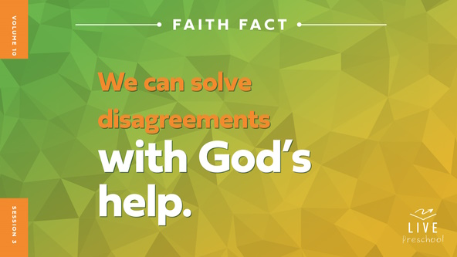

Let’s say our Faith Fact together. **We can solve disagreements with God’s help.** Let’s focus on and emphasize the last three words because those are the most important words to remember. *(Demonstrate.)* Let’s all try it. **We can solve disagreements with God’s help.** Awesome! Let’s do that one more time. **We can solve disagreements with God’s help**.

**Bible Time**

God helps us with so many things. Learning how He helped people in the Bible shows us what to do. We’ve got someone special who explores Bible stories with us. Let’s see what Lizzy is doing.

• *Play* ***Bible Lesson Video A****.*

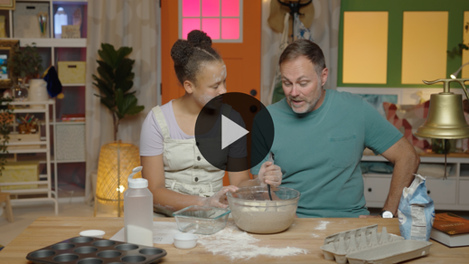

I’m so glad we get some time to think about that answer. We’ll come back to see what happens next in our Bible story, but first, let’s worship God.

**Worship**

We can show God how much we love Him by obeying Him when we learn His truth. We also show God we love Him through praise and worship. God hears our praise and sees our hearts worshipping Him.

**Praise**

Who wants to thank God for helping you in everything? Wave your hands up high. *(Group response)*

Are you glad we can always trust God? Give yourself a big hug. *(Group response)*

Who wants to tell God how much you love Him? Spin around three times. *(Group response)*

**Sing**

We can also worship God with our voices. The Bible gives us examples of how people would sing to worship God, so let’s do that now.

• *Lead the kids in singing one or two songs. See song suggestions at the beginning of the session.*

**Prayer**

What a beautiful sound it is to hear your voices praising God! I love worshipping God with you, and I love praying with you. Let’s talk to God together now.

|  |
| --- |
| *Dear God, thank You for always loving us. You promise to take care of us and to hold us close. We praise You for how great You are. We love You. Amen.* |

**Bible Time cont’d**

Grandpa and Lizzy will be back soon! We need to think about the answer to what happens next in our Bible story. Everyone put on your thinking cap *(demonstrate).* What do you think? Did Paul and the other believers yell at each other? *(Point to the angry face graphic.)* Or were they kind to each other as they talked? *(Point to the kind face graphic.)*

If you think Paul and the believers yelled at each other, show me your angry face. If you think they treated each other kindly, show me your kindest smile. Ready? Choose your answer.

• *Pause while kids respond.*

Let’s find out if you’re right! Here are Lizzy and Grandpa.

• *Play* ***Bible Lesson Video B.***

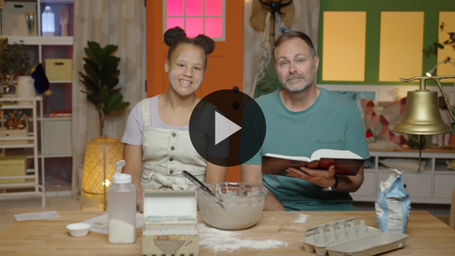

Wow, what a great story to show us how God can help us when we have disagreements with our friends and family! He knows that there will be times when we will disagree with others, so He wants us to know what to do when that happens. Isn’t God good to help us in every way, including our disagreements with people? *(Group response)*

**Response Time**

*Play a worship song quietly.*

Let’s respond to what we’ve learned from God’s Word today as we pray together. Can you put your hands on top of your heart? *(Demonstrate.)* When our heart is close to God, He helps us love others with His love. Let’s ask God to help us treat others with kindness even when we disagree.

• *Have the kids repeat phrases of the prayer after you.*

|  |
| --- |
| *Dear God, thank You for helping me when I need help. I’m glad that includes times when I disagree with people I love. Help me to serve You and treat others with Your kindness and love. Amen.* |

**Faith Verse**

Learning God’s Word is a great way to keep our hearts close to God. We’ve been practicing a Faith Verse. Let’s see how much we can remember as we say it together.

[Ephesians 4:3](https://ref.ly/logosref/Bible.Eph4.3) (NLT)

Make every effort to keep yourselves united in the Spirit, binding yourselves together with peace.

• *Play* ***Faith Verse Video****.*

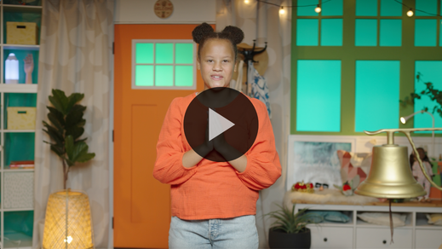

**Ephesians** *(hands at waist, spread apart, palms up and out)*

**4:** *(hands together like a clap)*

**3** *(hands opened to “book”)*

**Make every effort** *(sweep hands out and to the sides)*

**to keep yourselves united** *(bring hands together in a clap)*

**in the Spirit,** *(clap twice with the syllables of “Spirit”)*

**binding yourselves together** *(wrap arms around like a hug)*

**with peace.** *(bow head and whisper)*

**Closing**

Wave your hand at me if you’ve learned more about God’s Word today. *(Group response)* Great! It was so fun to worship God together by singing and praying. Who remembers how Paul and the other believers treated each other when they disagreed? *(Group response)* Yes, they were kind to each other. Who helped them solve their disagreement? *(Group response)* God did. Thanks for learning more about that with me today.

• *Play the* ***Faith Fact Sound*** *video (bell ringing).*

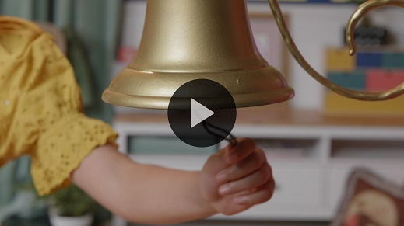

I think I heard our Faith Fact sound. Stand up if you think it’s time to say our Faith Fact one more time. **We can solve disagreements with God’s help**.

• *Show the* ***Faith Fact Slide.***



Let’s say it with our kindest voices. Ready? **We can solve disagreements with God’s help**. Turn to the friend next to you, and we’ll say it to each other. **We can solve disagreements with God’s help**.

**Dismissal to Small Groups**

Great job! Now it’s time to go have fun with our friends and leaders in our very special small groups.

• *Dismiss the kids by groups.*

|  |
| --- |
| ***Leader Tip:*** *This can be done by assigning color teams or by age groups. Note that some young preschoolers may not know their age. Using a colored sticker, jersey, or wristband will help separate the kids and help identify their small groups.* |

**Small Group**

**25 Minutes**

*See supplies and prep instructions at beginning of session or in each activity below.*

|  |
| --- |
| ***Leader Tip:*** *Small groups can alternate to each circle, or all groups can do each activity at the same time. If you choose to alternate, you will need at least one leader per circle.* |

**Circle 1**

**Group Connection**

**One Piece at a Time**

|  |
| --- |
| ***You Will Need***  *• Boxed small puzzles with about twenty-five pieces, one per group*  *No prep needed for this activity.* |

We’ve learned that we can solve our differences with God’s help. In our Bible story, Paul and some others didn’t see things the same way, but God helped them. Sometimes we will have disagreements about what we think is right or even best. It can be something small or something big. When we have disagreements, we need to pause and listen to each other.

• *Hand each kid a piece of the puzzle. If your group is small, each kid may get more than one puzzle piece.*

Look at the puzzle pieces I just gave you. Each one is different. They have different shapes, edges, and pictures on them. Although our pieces are different, we can put our pieces together to help make this amazing picture. *(Hold up the box.)* Let’s show our pieces to each other.

If you think you have a piece that fits with someone else’s, put them together. We’ll keep working together until we have the puzzle put together.

• *Work together to complete the puzzle. During the activity, interrupt and practice the Faith Fact:* **We can solve disagreements with God’s help**.

• *Play the* ***Faith Fact Sound*** *video****.*** *Review the Faith Fact even if you can’t play the sound.*



**Circle 2**

**Activity Page Time**

**Spot the Differences**

|  |
| --- |
| ***You Will Need***  *•* ***Small Group Activity Page****, one per kid*  *• Crayons or markers*  ***Getting Ready***  *• Print the* ***Small Group Activity Page****, one per kid.* |

God wants to help us when we disagree with others. That is what our Faith Fact says. Can anyone say our Faith Fact? (*Allow responses.)* Great job! Let’s all say it together. Ready? **We can solve disagreements with God’s help**. Disagreements can be as small as liking something different from someone else like a favorite cookie flavor. Sometimes the differences can be big. That’s when we may need God’s help.

• *Hand out a copy of the* ***Small Group Activity Page*** *and crayons to each kid.*

For our Activity Page, you’ll have to look closely to see how many differences you can find between the top and bottom pictures on your page. There are six differences in these pictures. If you get stuck, ask one of your friends if they can help you find the other differences. Working together might be better than doing it alone.

• *Give kids time to finish the* ***Small Group Activity Page.***

Great job! Let’s pray and ask God to help us with disagreements and differences we may have with others. Pray after me.

|  |
| --- |
| *Dear God, thank You for always being with me. I pray that You will help me to have Your love for people. Help me to be kind and patient with other people when I don’t agree with them. I want to show them Your love. Amen.* |

**Circle 3**

**Feet-to-Floor Game Time**

**Knock Down Disagreements**

|  |
| --- |
| ***You Will Need***  *• Blocks*  *• Tennis balls*  *• Floor-safe tape*  ***Getting Ready***  *• Use floor-safe tape to make a throwing line about eight feet from the block area.*  *• Stack blocks in a set of six (three as base, two on the middle row, and one on top) at the far end of the room.* |

Does anyone want to play a game? *(Group response)* Great! We have a super fun one planned. Our Faith Fact is **We can solve disagreements with God’s help.** In our Bible story, we saw that people who loved Jesus had some big disagreements. Sometimes, we will disagree with other people. The great thing is that when we have disagreements, God will help us. We need to be kind and patient with one another. God has given us something to help us know what is right and what is wrong—the Bible. He has also given us the Holy Spirit to help guide us.

In our game, we’ll let these blocks represent disagreements. *(Point toward the blocks.)* Don’t worry. We have something to help take care of those. *(Hold up tennis balls.)* These tennis balls represent God’s Word. We will all take turns rolling the ball toward the blocks, trying to knock them down. If you knock down all your blocks, shout the Faith Fact. Then, walk over and stack them back up. Let’s play!

• *Allow kids to take turns rolling the tennis ball at the blocks.*

Wow! Great job! I hope you will always remember when you don’t agree with someone that you can trust God and His Word more than anything else. **We can solve disagreements with God’s help**.

**Circle 4**

**Hands-On Learning**

**One United Family**

|  |
| --- |
| ***You Will Need***  *•* ***Small Group Hands-On Page****, one per group plus extras*  *• Scissors*  ***Getting Ready***  *• Copy the* ***Small Group Hands-On Page****, one per group plus extra copies for practice.*  *• Cut out the heart along the outside edge.* |

Our Faith Verse teaches us that we can be united with others. Even though we have differences, we can have peace with God’s help. Let’s say our Faith Verse together.

• *Lead kids in saying the Faith Verse with actions.*

[Ephesians 4:3](https://ref.ly/logosref/Bible.Eph4.3) (NLT)

Make every effort to keep yourselves united in the Spirit, binding yourselves together with peace.

**Ephesians** *(hands at waist, spread apart, palms up and out)*

**4:** *(hands together like a clap)*

**3** *(hands opened to “book”)*

**Make every effort** *(sweep hands out and to the sides)*

**to keep yourselves united** *(bring hands together in a clap)*

**in the Spirit,** *(clap twice with the syllables of “Spirit”)*

**binding yourselves together** *(wrap arms around like a hug)*

**with peace.** *(bow head and whisper)*

It can be difficult when we start adding more people to what we are doing. The more people there are, the more differences we might have. With God’s help, we can have peace. God wants our heart to be kind toward others and tied together in love.

• *Hold up the heart so the lines don’t show.*

If I cut a hole in this heart, do you think all of us could fit our hands inside at the same time? *(Group response)* Probably not. There are way too many of us, so it would probably tear the heart.

• *Fold the heart in half with the lines showing. Then, cut along the lines. When you’re done, it will open up into a very large shape.*

Whoa! That is a huge heart! When God helps us, He gives us His love for others, and that is way bigger than our love. I definitely think we can all fit our hands in there now. Let’s all try.

• *Lay the heart on the floor or a table and have the kids put their hands in the heart without pulling on it.*

That’s pretty amazing! As we grow in our relationship with God, He wants our heart tied together with others like our Faith Verse says. Let’s say our Faith Verse together one more time. Ready?

[Ephesians 4:3](https://ref.ly/logosref/Bible.Eph4.3) (NLT)

Make every effort to keep yourselves united in the Spirit, binding yourselves together with peace.

*Optional ending:* This heart doesn’t just represent all of us being in unity. It also represents how we can show God’s love to others even when we have disagreements. When we do that, He surrounds all of us with His love. Let me show you what I mean because God’s love is pretty awesome, and we can share it with others.

• *Open up the heart and spread it out on the floor.*

• *Invite one kid to stand in the middle of it without touching it. Have the other kids gather around and carefully hold onto the heart. Then, lift it up and over the kid’s head to represent God’s love for them.*

• *Repeat with other kids as long as the paper holds together.*

**Dismissal**

• *Play the* ***Faith Fact Sound*** *video (bell ringing).*



• *Show the* ***Faith Fact Slide.***



Today has been so much fun. I loved getting to pray, play, and praise with you. I’m excited about everything God is teaching us. Before we go let’s say the Faith Fact together one last time. **We can solve disagreements with God’s help.** Amazing job! I had a great time learning more about God’s Word with you. See you next time!

• *Send home the* ***Small Group******Activity Page*** *with each kid.*

• *Remind parents that there are* ***Family Devotions*** *available on the app to do with their kid.*

• *Tell everyone the date and time for the next session.*